

MINOR PROJECT REPORT
ON
Speech Emotion Detection and Speaker Identification using Machine Learning

submitted in partial fulfilment of the requirements for the award of degree of

AMITY SCHOOL OF ENGINEERING AND TECHNOLOGY

Submitted by: Supervised By:
Sukhman Arora Dr. Lokesh Pawar
A25305223154 Assisstant Professor
Amity University, Mohali

AMITY UNIVERSITY PUNJAB, MOHALI, INDIA

CONTENTS

Title Page No.
Abstract i
- Introduction 1
- Methodology 2
- Tools and Technologies 6
- Implementation 7
- Major Findings /Outcomes / Results 11
- Conclusion and Future Scope 12
References

Abstract
Human speech is one of the richest forms of communication. Beyond conveying words, speech signals carry emotional tone, speaker identity, and conversational context. The automatic interpretation of these signals using artificial intelligence is a growing research area with applications across healthcare, education, customer service, and human-computer interaction.
This project presents the design and partial implementation of a Speech Emotion Detection and Speaker Identification system using machine learning techniques. The system uses the RAVDESS (Ryerson Audio-Visual Database of Emotional Speech and Song) dataset — a professionally recorded benchmark dataset containing 2452 speech recordings from 24 actors expressing 8 distinct emotions: neutral, calm, happy, sad, angry, fearful, disgusted, and surprised.
The system follows a five-stage pipeline: dataset collection and analysis, audio loading and visualization, audio preprocessing, feature extraction using Mel-Frequency Cepstral Coefficients (MFCC), and machine learning model training. At the current mid-term stage, the first four stages have been fully implemented and verified. All 2452 speech files have been preprocessed through amplitude normalization and silence trimming. A total of 40 MFCC coefficients have been extracted per audio file, producing a structured feature dataset of 2452 rows and 43 columns saved as mfcc_features.csv.
The planned completion of the project will include training machine learning classifiers such as Support Vector Machine (SVM) and Random Forest on the extracted features, building a speaker identification module using custom-recorded audio from local speakers, and generating a natural language output sentence describing the speaker and their emotional state.

- Introduction
Speech is the most natural and expressive form of human communication. When a person speaks, they convey far more than the literal meaning of their words. The tone, pitch, rhythm, and intensity of speech reveal the speaker's emotional state, level of confidence, and communication intent. For example, the same sentence "I am fine" can express happiness, sadness, sarcasm, or frustration depending entirely on how it is spoken.
The ability to automatically detect these emotional signals from speech audio is known as Speech Emotion Recognition (SER). SER systems analyze the acoustic properties of voice signals and map them to emotional categories. These systems have a wide range of practical applications. In healthcare, they can detect signs of depression or anxiety from patient speech. In customer service, they can identify frustrated callers and escalate calls automatically. In education technology, they can monitor student engagement and emotional state during online learning. Virtual assistants such as Siri and Alexa are also beginning to incorporate emotion-aware response systems.
Despite significant progress in recent years, speech emotion recognition remains a challenging problem. Emotions are subjective and vary across speakers, cultures, languages, and recording conditions. Most existing systems perform well on controlled laboratory datasets but struggle with real-world speech. Additionally, most systems focus only on emotion detection and do not simultaneously perform speaker identification.
This project addresses these challenges by building a system that combines emotion detection with speaker identification and speech type classification. The system is trained on the RAVDESS benchmark dataset and will be further enhanced using a custom-recorded dataset containing speech samples from local speakers including friends and teachers of the developer. The final system will produce a descriptive natural language sentence summarizing the speaker, their emotional state, and their speech type.
The motivation for this project comes from the growing need for emotionally intelligent AI systems. As voice interfaces become more common in daily life, the ability to understand not just what people say but how they say it becomes increasingly important. This project contributes a practical, reproducible implementation of such a system using widely available open-source tools.

- Methodology
The proposed system follows a five-stage pipeline to transform raw audio recordings into emotion and speaker predictions. Each stage is described in detail below.
- Dataset Collection and Analysis
The RAVDESS dataset was selected as the primary data source for this project due to its clean recording conditions, balanced emotion distribution, and well-documented file naming conventions. The dataset was downloaded and organized in the following folder structure:
Ravdess → Audio_Speech_Actors_01-24 → Actor_XX → [.wav files]
Each filename in the RAVDESS dataset encodes seven pieces of information separated by hyphens. For example, the filename 03-01-05-01-02-01-12.wav encodes: modality (03 = speech), vocal channel (01 = speech), emotion (05 = angry), emotional intensity (01 = normal), statement (02 = "dogs are sitting by the door"), repetition (01), and actor number (12). This naming convention was analyzed and implemented in code to programmatically extract emotion labels and actor identities from filenames without requiring a separate metadata file.
A dataset analysis script was written in Python to walk through all dataset folders, identify .wav files, and count speech versus song recordings. The analysis confirmed that the dataset contains 2452 speech recordings from 24 actors covering 8 emotion categories with the following distribution: neutral (188 files), calm (376), happy (376), sad (376), angry (376), fearful (376), disgust (192), and surprised (192). The slight imbalance between certain categories reflects the original RAVDESS recording design.
- Audio Loading and Visualization
Audio files were loaded using the Librosa library, a widely used Python package for audio and music signal analysis. The Librosa load function reads .wav files and returns the audio signal as a NumPy array along with the sample rate. All files were loaded at a standardized sample rate of 22050 Hz, which is the default sample rate used in Librosa and corresponds to the Nyquist frequency for human speech.
For each loaded audio file, the following properties were extracted and analyzed: sample rate (22050 Hz for all files), signal shape (number of samples), data type (float32), and duration in seconds. Waveforms were plotted using Matplotlib to visualize the time-domain representation of speech signals. These visualizations revealed clear differences in the amplitude patterns, rhythm, and energy distribution across different emotional states. For example, angry speech showed high energy throughout the recording, while calm speech showed lower and more uniform amplitude.
- Audio Preprocessing
Raw audio recordings vary in volume, duration, and the amount of silence at the beginning and end. These variations can introduce noise into the feature extraction process if not addressed. A preprocessing pipeline was implemented to standardize all recordings before feature extraction.
The preprocessing pipeline consists of three steps applied sequentially to every audio file.
- Audio Loading at Standard Sample Rate: Each .wav file is loaded at 22050 Hz using Librosa. Loading at a fixed sample rate ensures that all files are on the same temporal scale regardless of their original recording sample rate.
- Amplitude Normalization: The amplitude of each signal is normalized to the range [-1, 1] by dividing all sample values by the maximum absolute amplitude in the signal. This ensures that variations in recording volume across different actors, microphones, and sessions do not influence the feature extraction step. Without normalization, a loudly recorded angry utterance and a softly recorded angry utterance would produce different MFCC features even though they express the same emotion.
- Silence Trimming: Leading and trailing silence is removed from each recording using Librosa's trim function with a top_db threshold of 20 dB. This removes portions of the recording where the signal level is more than 20 dB below the peak level, which corresponds to silence or near-silence. Trimming reduces the total duration of each recording while retaining all speech content, which makes the subsequent feature extraction more focused on actual speech rather than silence.
The results of this preprocessing pipeline were verified by comparing the raw and trimmed signal lengths across all emotion categories. On average, silence trimming reduced signal length by 10–25%, with variations depending on the emotion expressed. Mel spectrograms were also generated to visually verify that preprocessing preserved the speech content while removing unwanted silence.
- MFCC Feature Extraction
Mel-Frequency Cepstral Coefficients (MFCC) are the core feature representation used in this project. MFCCs are a compact numerical representation of the spectral characteristics of speech that closely models how the human auditory system perceives sound.
The MFCC extraction process works as follows. The preprocessed audio signal is divided into short overlapping frames of approximately 25 milliseconds. For each frame, the Fast Fourier Transform (FFT) is computed to obtain the frequency spectrum. The spectrum is then mapped onto the mel scale, which is a perceptual scale that compresses high-frequency bins and expands low-frequency bins to match human hearing sensitivity. A filterbank of triangular filters is applied to the mel-scaled spectrum, and the logarithm of the filterbank energies is computed. Finally, the Discrete Cosine Transform (DCT) is applied to produce the final MFCC coefficients, which are decorrelated and compact representations of the spectral envelope.
For this project, 40 MFCC coefficients are extracted per audio file using Librosa's mfcc function. This produces a 2D array of shape (40, T) where T is the number of time frames. To produce a fixed-length feature vector suitable for machine learning, the mean value of each coefficient across all time frames is computed, collapsing the 2D array into a 1D vector of 40 values. This mean MFCC vector represents the average spectral characteristics of the entire speech recording.
The feature extraction was applied to all 2452 speech files in the RAVDESS dataset. The results were stored in a structured Pandas DataFrame with 40 MFCC feature columns, one emotion label column, one actor ID column, and one filename column, giving a total of 43 columns. This feature dataset was saved as mfcc_features.csv with 2452 rows, one per recording. This CSV file represents the complete numerical dataset that will be used for machine learning model training in the next phase of the project.
MFCC heatmap visualizations were generated for one sample file from each of the 8 emotion categories to visually verify that different emotions produce distinguishable MFCC patterns. These visualizations confirm that emotions such as angry and fearful produce markedly different coefficient distributions compared to neutral and calm speech, validating the effectiveness of MFCC as a discriminative feature for emotion classification.
- Machine Learning Model Training
The fifth stage of the system involves training machine learning classifiers on the extracted MFCC features to predict emotion and speaker identity from new audio inputs.
The mfcc_features.csv dataset generated in the previous stage will be split into training and testing sets using an 80/20 ratio. Three classifiers will be trained and evaluated using the Scikit-learn library — Support Vector Machine (SVM) with a radial basis function kernel, Random Forest with 100 decision trees, and Logistic Regression as a baseline comparison. Model performance will be measured using accuracy, precision, recall, F1 score, and a confusion matrix.
In addition to emotion classification, a separate speaker identification model will be trained using custom-recorded audio from local speakers. The same 40 MFCC features will be used as input, with speaker name as the target label.
The final prediction system will combine both models to generate a natural language output sentence describing the speaker and their emotional state. This stage will be completed before the end-term evaluation.
- System Architecture
The complete system architecture follows a linear pipeline from raw audio input to natural language output. The architecture is described below in sequential stages.

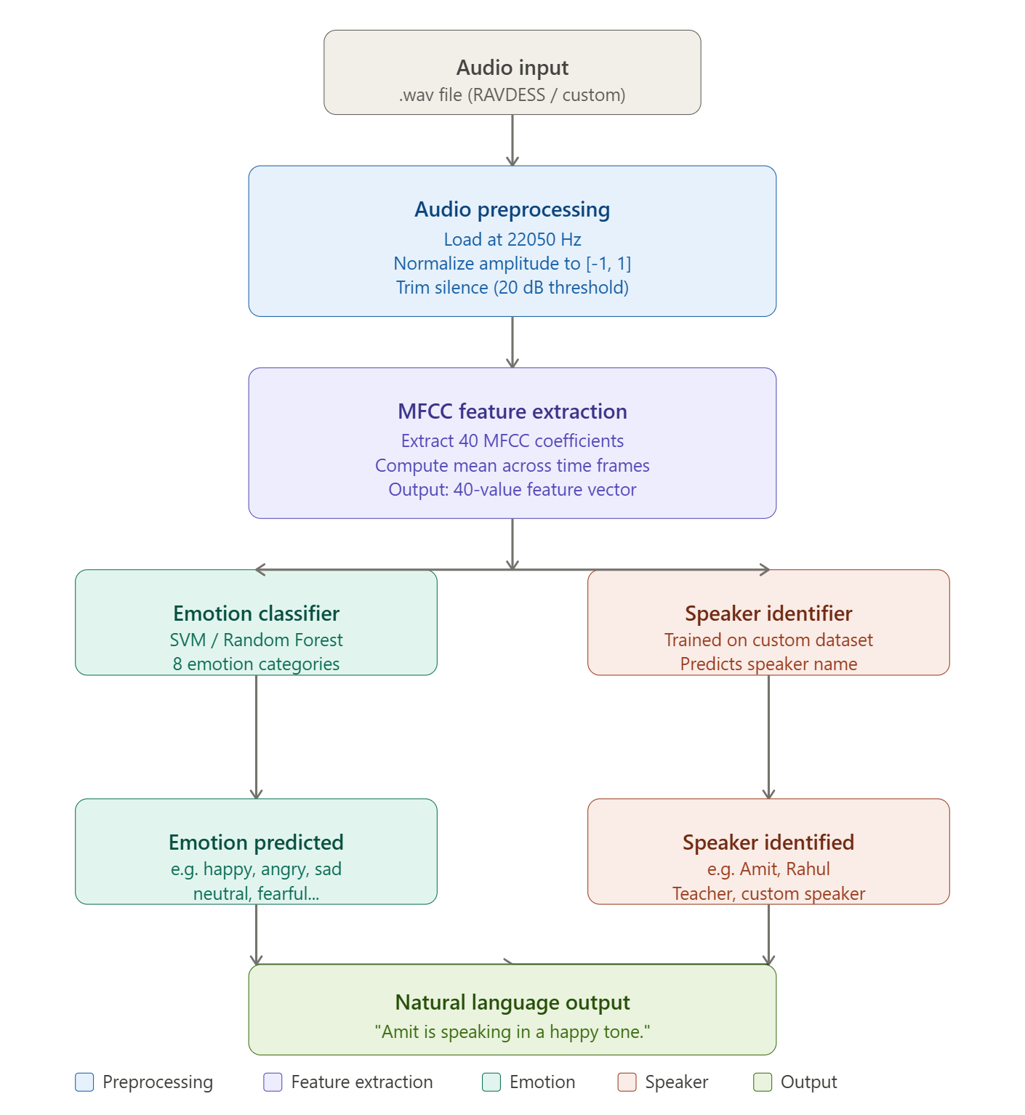
Figure 2.1 System architecture diagram showing the complete pipeline from audio input to natural language output
- Tools and Technologies
Component | Tool / Library | Purpose
Programming Language | Python 3.x | Core development language
Audio Processing | Librosa 0.10 | Loading, preprocessing, MFCC extraction
Numerical Computation | NumPy | Array operations on audio signals
Data Visualization | Matplotlib | Waveform and spectrogram plots
Data Management | Pandas | Feature dataset creation and CSV export
Machine Learning | Scikit-learn | SVM, Random Forest, evaluation metrics
Audio Recording | SoundDevice + SoundFile | Custom dataset recording
Development Environment | Visual Studio Code | Code development and testing
Version Control | GitHub | Code repository and version management
Dataset | RAVDESS | Primary emotional speech benchmark dataset

- Implementation
This section describes the actual implementation of the project pipeline with code details and execution results.
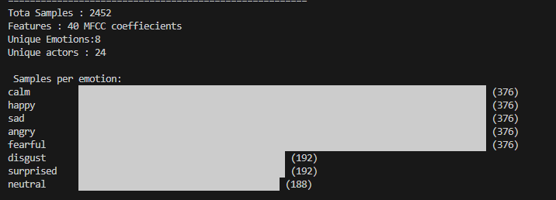
- Dataset Analysis : A Python script named dataset_analysis.py was developed to analyze the structure of the RAVDESS dataset. The script uses the os.walk() function to recursively traverse all dataset folders and identify .wav audio files. Files are filtered based on the modality code present in the filename — code 03 indicates speech recordings while code 02 indicates song recordings. Only speech files are selected for further processing. The script successfully identified 2452 speech files distributed across 24 actors covering 8 emotion categories. The terminal output confirming this analysis is shown below. The basic file count was obtained from dataset_analysis.py. The detailed emotion-wise distribution shown below was obtained from feature_extraction.py.
Figure 4.1: Terminal output of feature_extraction.py showing successful processing of 2452 speech files, emotion distribution across 8 categories, and 24 unique actors from the RAVDESS dataset
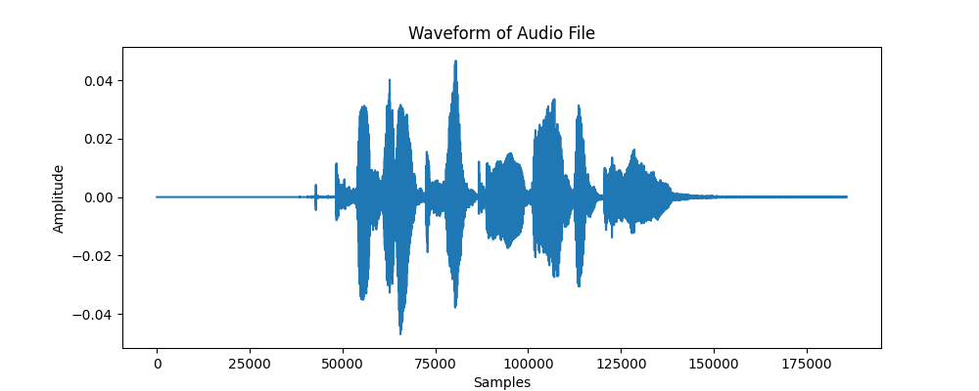
- Audio Loading and Visualization: A Python script named audio_analysis.py was developed to load individual audio files and extract their basic properties. The script uses the librosa.load() function to read .wav files at a standardized sample rate of 22050 Hz. For each file the script identifies the modality type from the filename, prints the sample rate, signal shape, data type, and duration in seconds, and generates a waveform plot using Matplotlib. The waveform plot shows the amplitude of the speech signal over time, allowing visual inspection of the speech recording. The waveform output for a sample file is shown below.
Figure 4.2: Waveform plot generated by audio_analysis.py showing time-domain representation of a RAVDESS speech recording loaded at 22050 Hz sample rate using Librosa
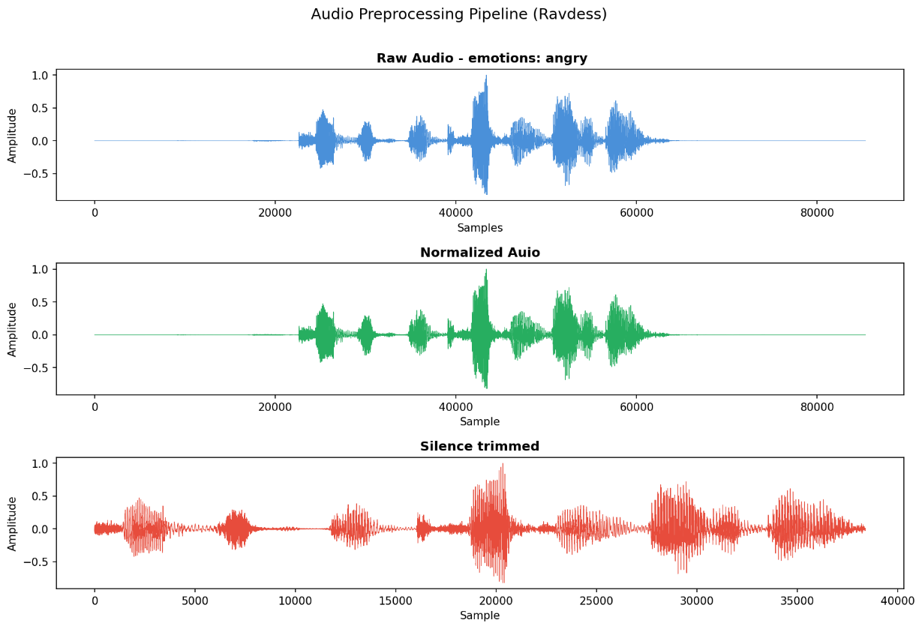
- Audio Preprocessing: A Python script named preprocessing.py was developed to clean and standardize all audio recordings before feature extraction. The script implements three preprocessing steps on every audio file. First, each file is loaded at 22050 Hz using Librosa. Second, amplitude normalization is applied by dividing all sample values by the maximum absolute amplitude, scaling the signal to the range [-1, 1]. Third, leading and trailing silence is removed using librosa.effects.trim() with a 20 dB threshold. The preprocessing results were verified across all 8 emotion categories and confirmed that silence trimming reduced average signal length by 10–25% while retaining all speech content. A mel spectrogram was also generated to visually confirm that frequency patterns were preserved after preprocessing. The outputs are shown below.
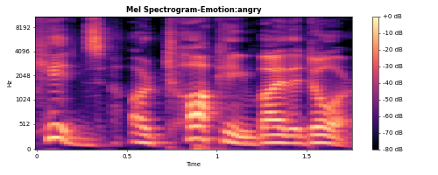
Figure 4.3: Output of preprocessing.py showing three stages of audio preprocessing — raw audio signal (top), amplitude normalized signal (middle), and silence trimmed signal (bottom)
Figure 4.4: Mel spectrogram generated during preprocessing showing frequency energy distribution over time for a sample speech recording
- MFCC Feature Extraction: A Python script named feature_extraction.py was developed to extract Mel-Frequency Cepstral Coefficient features from all 2452 preprocessed speech files. The script applies the full preprocessing pipeline to each file and then calls librosa.feature.mfcc() to extract 40 MFCC coefficients. Since MFCC extraction produces a 2D array of shape (40, T) where T varies across files, the mean value of each coefficient across all time frames is computed to produce a fixed-length 1D feature vector of 40 values per file. This ensures all samples have uniform dimensions suitable for machine learning model input. The 40 MFCC values along with the emotion label, actor ID, and filename are stored as one row in a Pandas DataFrame. After processing all 2452 files the complete feature dataset was saved as mfcc_features.csv containing 2452 rows and 43 columns. MFCC heatmap visualizations were also generated for one sample from each emotion category to visually confirm that different emotions produce distinct coefficient patterns. The outputs are shown below.
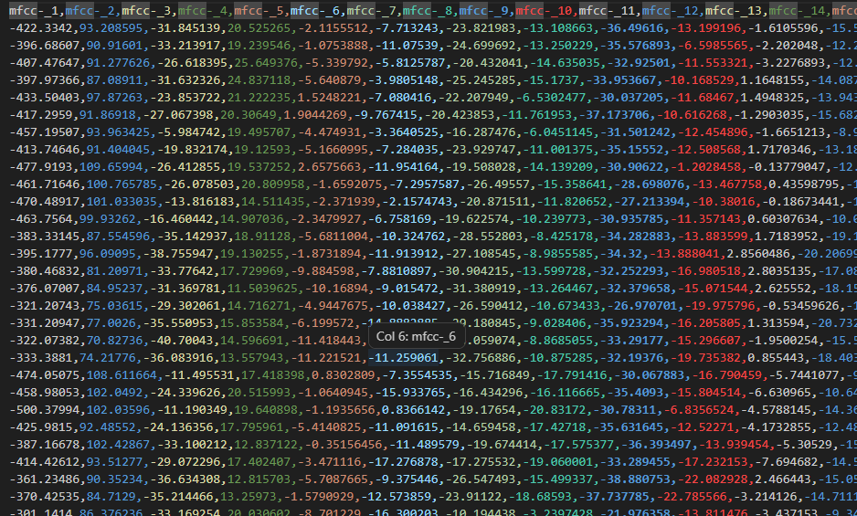
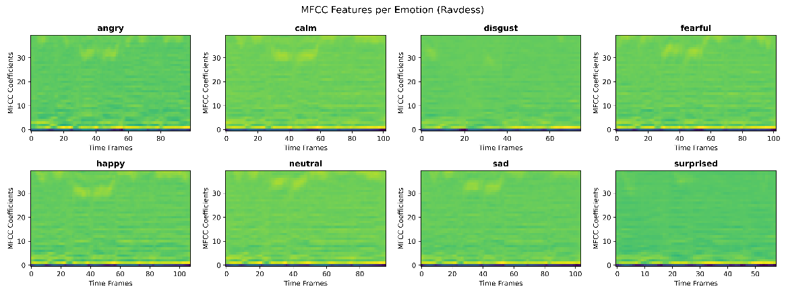
Figure 4.5: MFCC heatmap visualization generated by feature_extraction.py showing 40 coefficient patterns across time frames for all 8 emotion categories — angry and fearful show visibly higher energy compared to neutral and calm
Figure 4.6: mfcc_features.csv opened in Excel showing the complete extracted feature dataset — 2452 rows and 43 columns including 40 MFCC coefficient values, emotion label, actor ID, and filename per recording
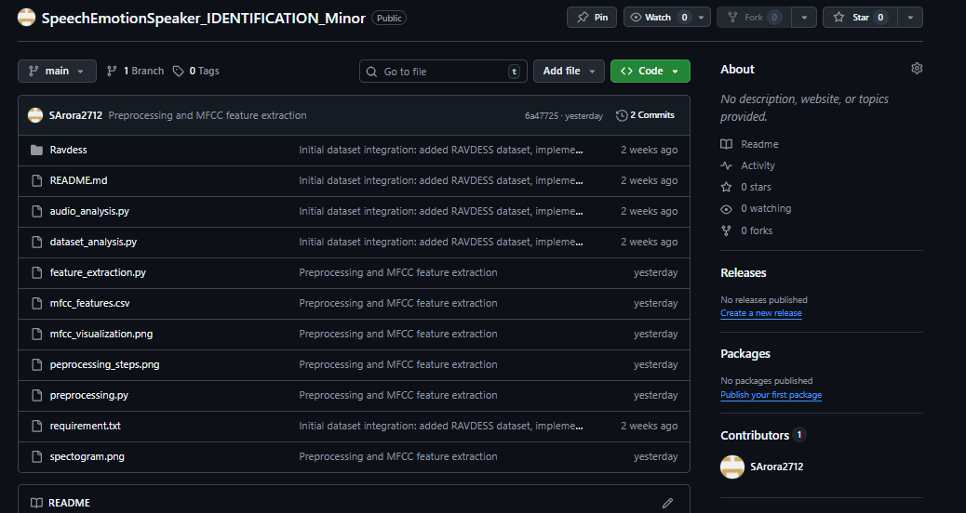
- GitHub Repository: All project code files are version controlled and maintained in a GitHub repository, ensuring organized development and easy access during evaluation. The repository contains five files — dataset_analysis.py, audio_analysis.py, preprocessing.py, feature_extraction.py, and record_dataset.py — covering all stages of the project completed at mid-term.
Figure 4.7: GitHub repository showing all 5 project code files committed — dataset_analysis.py, audio_analysis.py, preprocessing.py, feature_extraction.py, and record_dataset.py

- Major Findings /Outcomes / Results
The following findings and outcomes have been achieved at the mid-term stage of the project:
  - Findings at Mid-Term
- 2452 speech files successfully identified and processed from the RAVDESS dataset
- 8 distinct emotion categories confirmed with balanced distribution across 24 actors
- Preprocessing pipeline reduced average signal length by 10–25% through silence trimming
- 40 MFCC coefficients successfully extracted from all 2452 speech files
- Structured feature dataset mfcc_features.csv generated with 2452 rows and 43 columns
- MFCC heatmap visualizations confirm distinct spectral patterns across all 8 emotion categories
- Expected Results after Model training
Emotion Classification Accuracy: Based on published research using MFCC features with SVM classifiers on the RAVDESS dataset, an accuracy of approximately 65–75% is expected on the test set. Accuracy may vary across emotion categories, with highly distinct emotions such as angry and happy expected to show higher classification accuracy than more similar emotions such as calm and neutral.
Speaker Identification: The speaker identification module, trained on custom-recorded audio, is expected to correctly identify speakers from a small set of known individuals with high accuracy due to the relatively small number of speakers and controlled recording conditions.
Sample Output Sentences:
- "Amit is speaking in an angry tone."
- "Rahul appears to be expressing happiness while conversing."
- "The teacher is speaking in a calm tone while explaining a concept."
- "The speaker sounds fearful based on the detected speech patterns."

- Conclusion and Future Scope
This project presents a systematic approach to building a speech emotion detection and speaker identification system using machine learning. At the mid-term stage, a complete preprocessing and feature extraction pipeline has been successfully implemented and verified on the RAVDESS dataset. All 2452 speech files have been processed, and a structured feature dataset of 2452 rows and 40 MFCC features per sample has been generated and saved.
The work completed demonstrates a strong understanding of audio signal processing, feature engineering, and the RAVDESS dataset structure. The preprocessing pipeline ensures data consistency, and the MFCC feature visualizations confirm that emotionally distinct speech produces distinguishable coefficient patterns suitable for machine learning classification.
The remaining work involves training machine learning classifiers on the extracted features, building a speaker identification module using custom-recorded data, and developing the final output sentence generation system. These components will be completed and demonstrated at the end-term evaluation.
This project contributes a practical, reproducible implementation of speech emotion recognition that combines a standard benchmark dataset with custom local speaker data, making the system more applicable to real-world conversational speech scenarios.
In terms of future scope, the current system can be enhanced in several ways. Deep learning models such as Convolutional Neural Networks applied to mel spectrograms can replace traditional classifiers for improved accuracy. The system can be extended to support real-time emotion detection from live microphone input using dedicated hardware devices such as the Blue Yeti microphone, JBL professional speakers, or the Rode NT-USB microphone for higher quality audio capture. The Mic Codex audio interface can be integrated to process multi-channel audio input simultaneously, enabling the system to handle multiple speakers in real-time conversations. The custom dataset can be expanded with more speakers, languages, and speech types to improve generalization across different demographics. Integration with a conversational AI interface would allow the system to respond intelligently based on the detected emotional state of the user. Additionally, the system can be deployed as a mobile or web application to make it accessible for practical use in education, healthcare, and customer service environments.

- References
- 1. Livingstone, S. R., & Russo, F. A. (2018). The Ryerson Audio-Visual Database of Emotional Speech and Song (RAVDESS). PLOS ONE, 13(5), e0196391. https://doi.org/10.1371/journal.pone.0196391
- McFee, B., Raffel, C., Liang, D., & Ellis, D. (2015). librosa: Audio and music signal analysis in Python. Proceedings of the 14th Python in Science Conference, 18–25. https://doi.org/10.25080/Majora-7b98e3ed-003
- Davis, S. B., & Mermelstein, P. (1980). Comparison of parametric representations for monosyllabic word recognition. IEEE Transactions on Acoustics, Speech, and Signal Processing, 28(4), 357–366.

